Build an e-commerce app with dot net core and Angular

1. Setup the environment
2. API Basics

Create a api project using following command and run the api application. Test ur default api in postman.

Cmd> mkdir shoppers stop

Cd shoppers stop

Dotnet –h

Dotnet new sln

Dotnet new webapi –o API

Dotnet sln –h

Dotnet sln add API

Dotnet sln list

Code..

To run the api from terminal

Cd api

Dotnet run

Dotnet dev-certs https

Dotnet dev-certs https –h

Dotnet dev-certs https –t

EntityFramework command

dotnet add package Microsoft.EntityFrameworkCore.Sqlite --version 3.1.0

dotnet ef –h

dotnet ef migrations add InitialCreate -o Data/Migrations

dotnet ed database –h

dotnet ef database update

Create a api controller for the project

Add C# entity class

Setting up the EF

Add a connection string

Add a EF migrations

Update DB

Reading data from database in the API

Postman Collections

Creating a Additional Projects

Save project in Github

git status

git init

git add .

git commit -m "Initial Commit"

git remote add origin https://github.com/PratibhaRepos1/shoppers.git

git push -u origin master

Summary of section2: API Basics

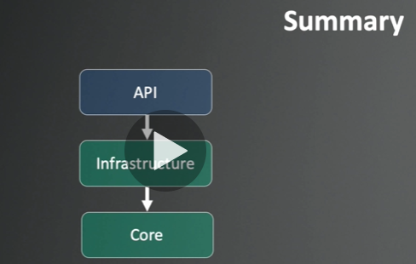

Section 3: API Architecture

Repository Pattern

Current Completed Architecture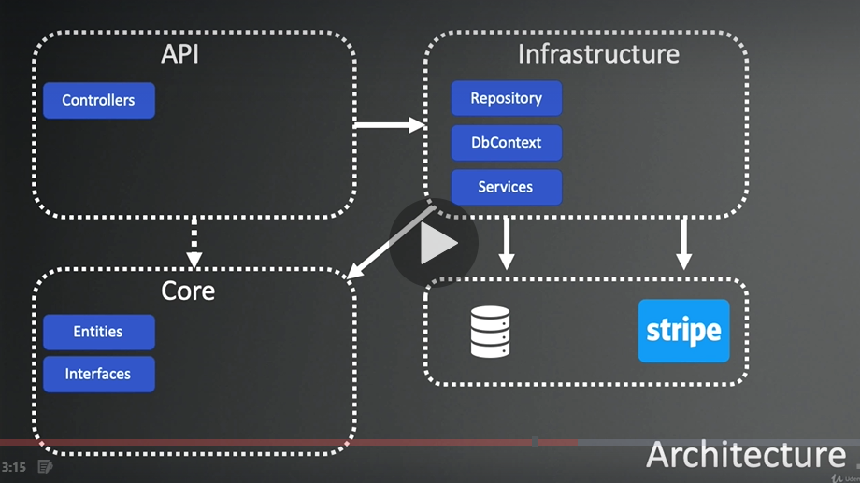

The Repository Pattern Goals:

* Decouple a business code from data access
* Separations of Concerns
* Minimize duplicate Query Logic
* Testability

Repository Pattern Consequences

* Increase a level of Abstraction
* Increased the Maintainability, flexibility and Testability
* More classes/interfaces – less duplicate code
* Business logic further away from the data
* Harder to optimized certain operations against the data source

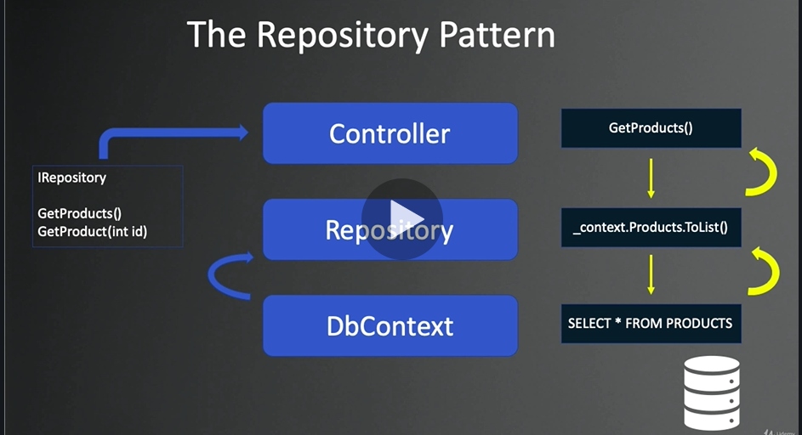

Adding